**THE UNIVERSITY OF AUCKLAND**

|  |
| --- |
| **SEMESTER ONE 2020**  **Campus: City** |

**COMPUTER SCIENCE and SOFTWARE ENGINEERING**

**Human Computer Interaction**

**TEST**

Student Name: Aiden Burgess

Student ID: 600280511

This work is my own. *Aiden Burgess*

**Q1: Heuristic Evaluation of a Website**

Browse for a cookbook with fancy, complicated recipes

**#1: Visibility of system status**

The system should always keep users informed about what is going on, through appropriate feedback within reasonable time.

**#8: Aesthetic and minimalist design**

Dialogues should not contain information which is irrelevant or rarely needed. Every extra unit of information in a dialogue competes with the relevant units of information and diminishes their relative visibility.

There are three levels of criticality: low, medium, and high. If an issue completely blocks a user from completing a task , then it is of high criticality, while an issue that annoys a user would be of low criticality.

|  |  |  |
| --- | --- | --- |
| **Usability issue** | **Criticality** | **Description** |
| *1. Visibility of System Status* | | |
|  | Medium | On mobile format, there is no information to indicate which page the user is currently on. |
|  | Medium | The user does not know how many results there are so may scroll for a long time before realising to search instead. |
|  | Low | No indication as to whether the user has previously viewed a book |
|  |  |  |
|  |  |  |
| *8. Aesthetic and Minimalist Design* | | |
|  | Medium | This information does not need to be placed at the bottom of each page and is not relevant to most users. |
|  | Low | Even after closing the warning, it persists after going to a new page. |
|  | Low | Unnecessary information about when the stock was updated. |
|  | Low | Google preview button does not fit the aesthetic of the website, so it looks out of place and unaesthetic. |
|  | Low | The Google preview button functionality is repeated by the “LOOK INSIDE” element. |
|  | Low | There is a lot of wasted space between the refine and sorting elements. |

**Q2.1: Design review**

The scenario that is being explored is a student looking to buy a cookbook with fancy, complicated recipes as a birthday present for a friend.

**Google preview button always present on mobile but not clickable – Subjective Satisfaction**

When using a mobile device, all books have the “Google Preview” button on the bottom right. Although this is a useful feature, the button does not do anything when clicked. This may confuse or frustrate the user.

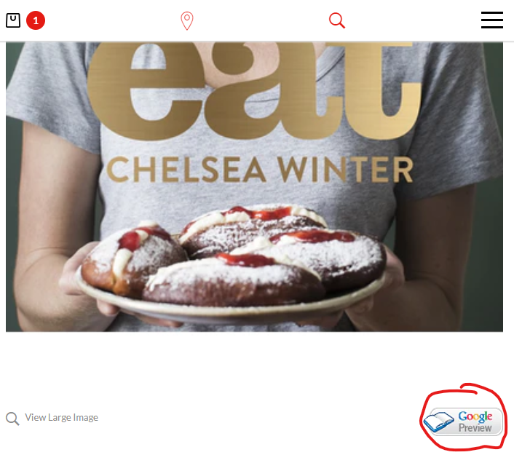

**Scrolling when reached end of categories – Error frequency and severity**

When scrolling through the sub-categories under the “BOOKS” category, the user may see the entire page scrolling down if the end of the list. Expecting the user to have this level of control is unreasonable and mildly frustrating.

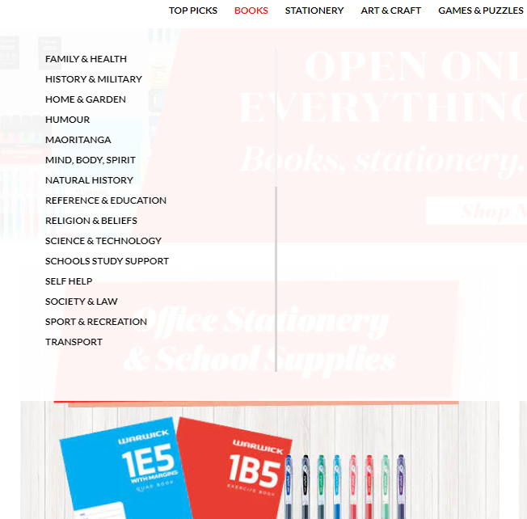

**Moving from left categories to right requires precision – Error Frequency and Severity**

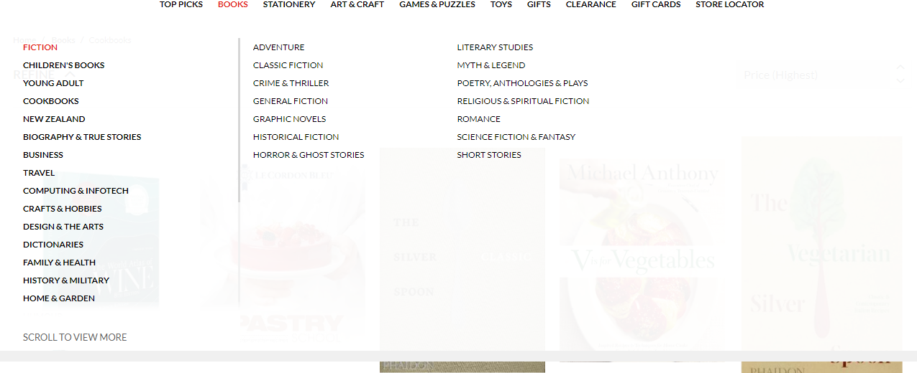After hovering on a sub-category in books, the space on the right is populated with sub-sub-categories. However, moving the cursor to reach these options is often difficult. Furthermore, in the mobile format, these sub-sub-categories are not visible, leading to inconsistency of use, decreasing memorability.

**Can’t click cookbooks – Efficiency of Use**

After the user clicks a cookbook, the breadcrumbs appear near the top of the page. However, the most specific (right-most) category is not clickable, and this is only distinguished for the user by a slight change in stroke-width.



**Some categories only have one book – Fit for Use**

Function of categories is to group similar items together. If a category only has one item should it does not provide extra functionality to the user.

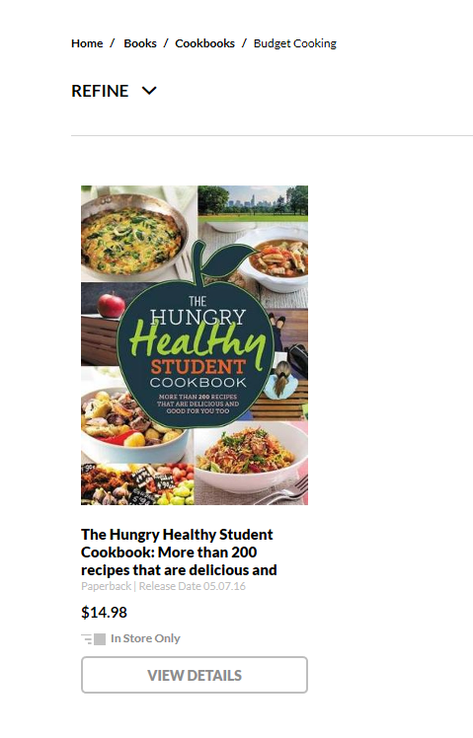

**Can’t click out of sorting - Ease of Learning**

When looking for a cookbook with fancy, complicated recipes, a user may try to sort the results. An issue with this dropdown menu is that after clicking it initially, it will only close if you click again on the dropdown. This behaviour contrasts with the expected behaviour of it closing automatically after the cursor is moved far enough away. This issue may annoy the user.

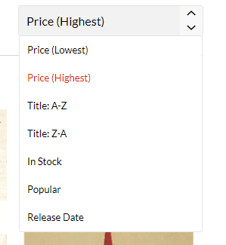

**Clicking refine a few times scrolls you down and makes you get stuck – Ease of Learning**

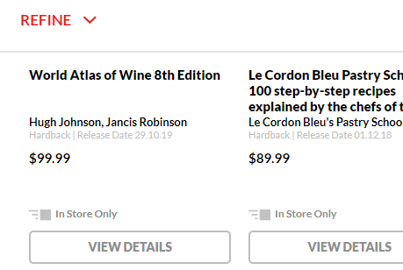If the refine button is clicked a few times, this can cause the page to be stuck at a certain point and prevent the user from scrolling. Although the outcome of finding this issue is major, the likelihood of finding it is quite low.

**Clicking the heart icon flashes a popup for a second then redirects to book page**

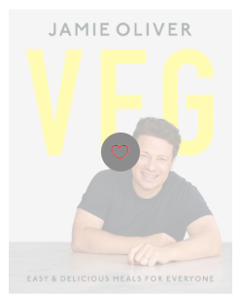Clicking the heart icon while hovering over a book results in a popup being shown for a brief second, then redirects the user to the book page. This issue would be encountered very commonly by users, but only causes slight confusion.

**Q2.2: Brainstorming a solution [on paper]**

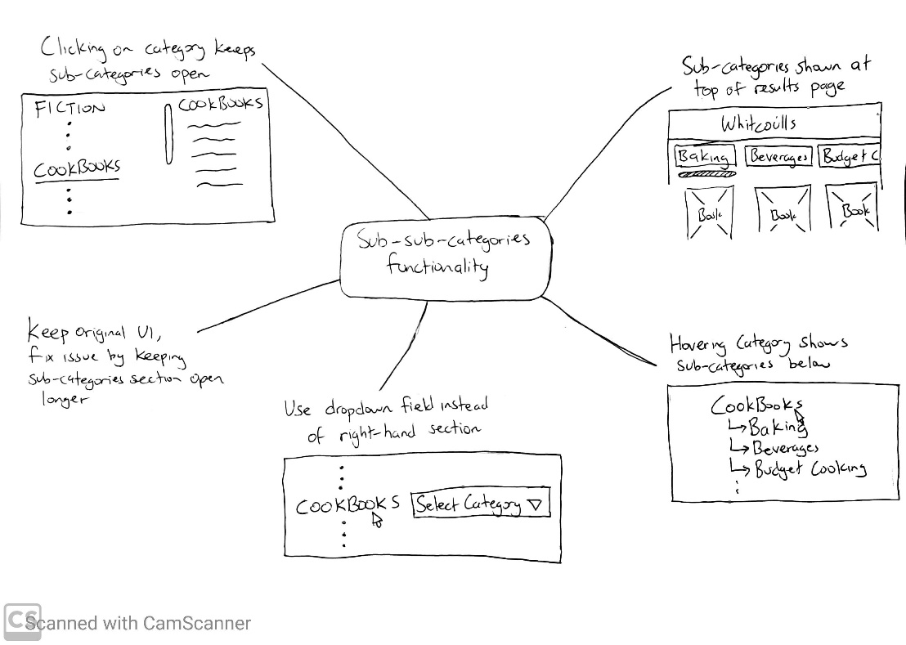

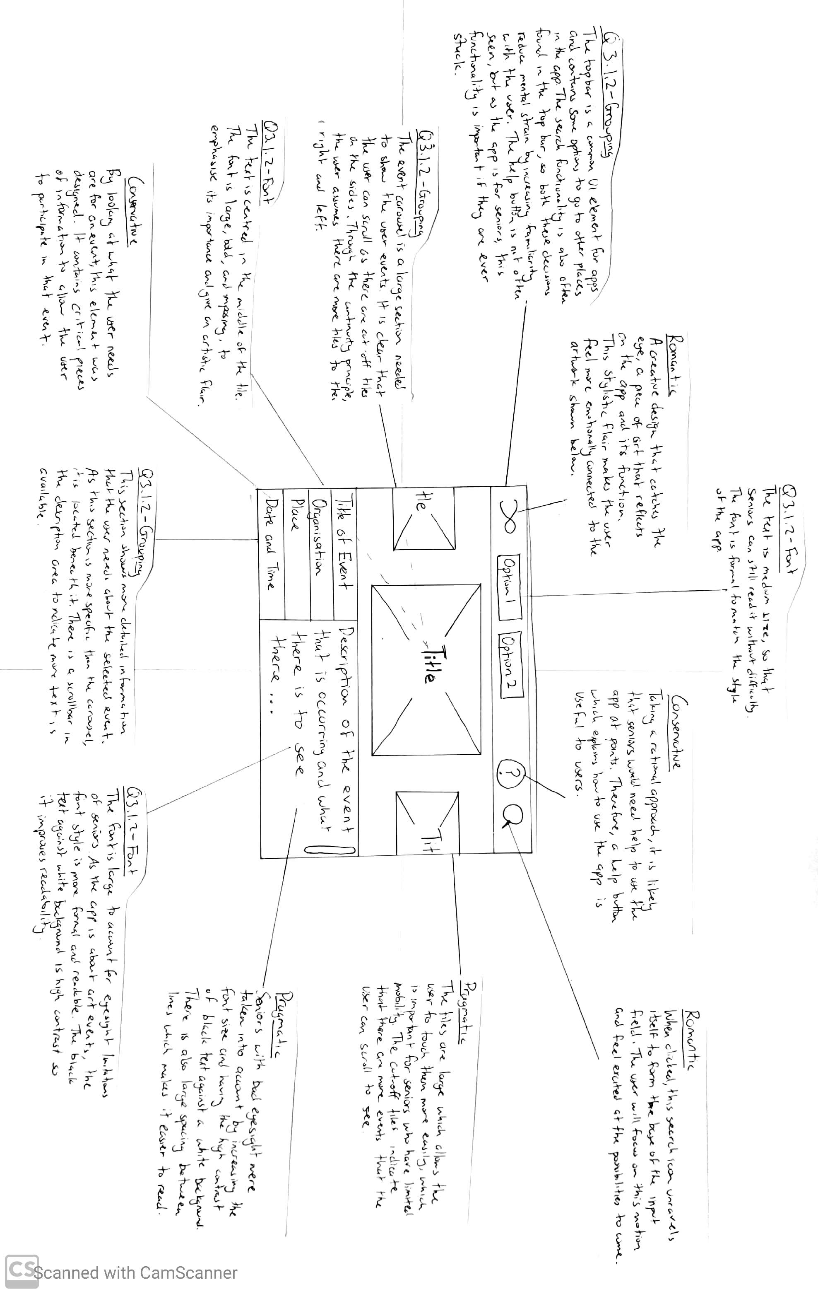

**Q3.1.1 Paper Prototype and Q3.1.2 Annotation of Visual Design**

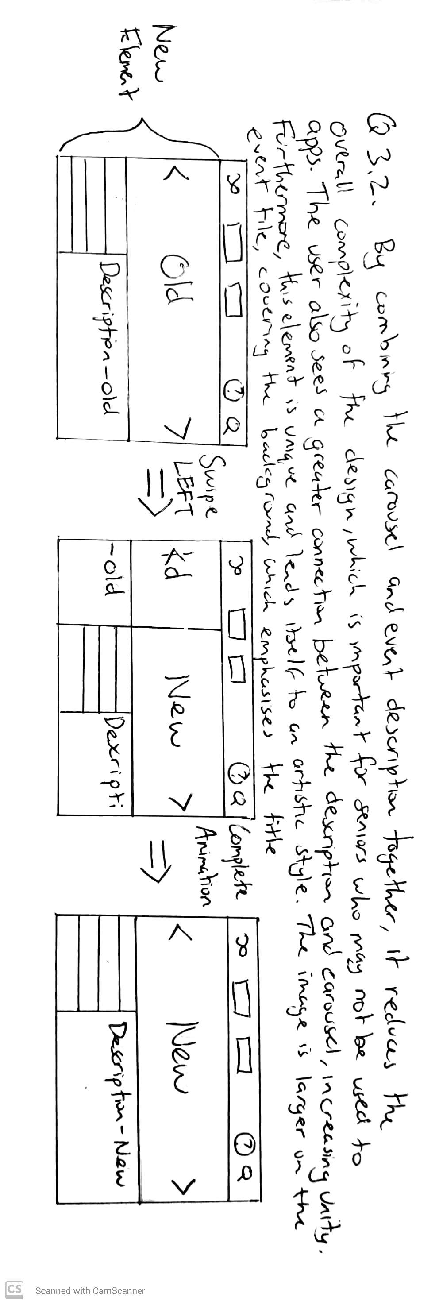**Q3.2 Sketch A Unique Element**